The Asian Pacific American Librarians Association’s
2016 President’s Program

From Vietnam to Syria: Refugees, Their Stories, and Needs

Co-Sponsored by APALA, IRRT, & REFORMA
Saturday, June 25, 2016 | 10:30-11:30am | OCCC W103B

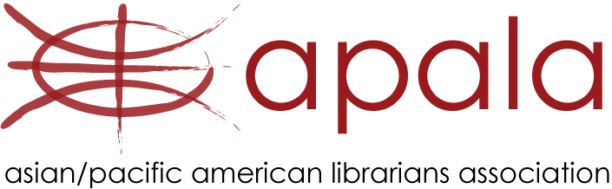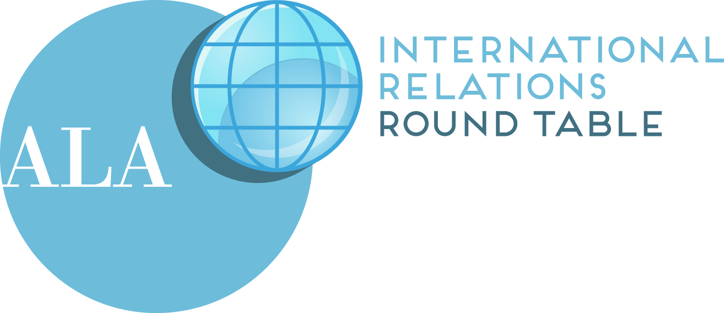

Moderator
The program will be Moderated by Janet H. Clarke,
APALA President, and Associate Dean, Research & User Engagement, Stony Brook University.

Speakers
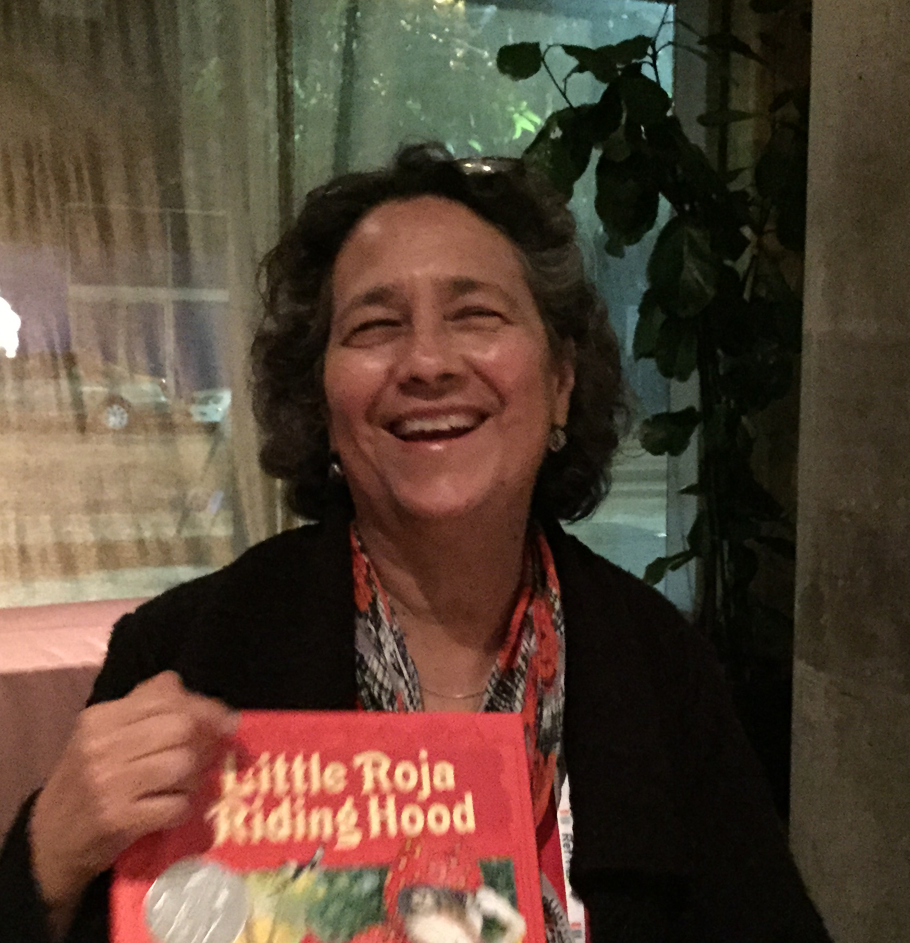
Oralia Garza de Cortés is a leading voice for bilingual and multicultural children’s literature and library services for Latino children. In 1996 she co-founded the Pura Belpré Award to promote quality children’s literature about the Latino experience written by Latino authors and illustrators and has worked tirelessly with Pat Mora to promote April 30th as El Día de los Niños / El día de los libros, through advocacy for family programs and activities that promote lifelong reading. She received the Advocacy Award from the Joint Conference of Librarians of Color in 2012 and in 2013 she was named to the Women in Library History Honor Roll by the Feminist Task Force of the American Library Association. In 2015 she was named by Library Journal as a Mover and Shaker in the area of Advocacy. Currently she co-chairs the REFORMA Children in Crisis Project, a project that aims to deliver books in Spanish to the incarcerated refugee children from El Salvador, Honduras and Guatemala.

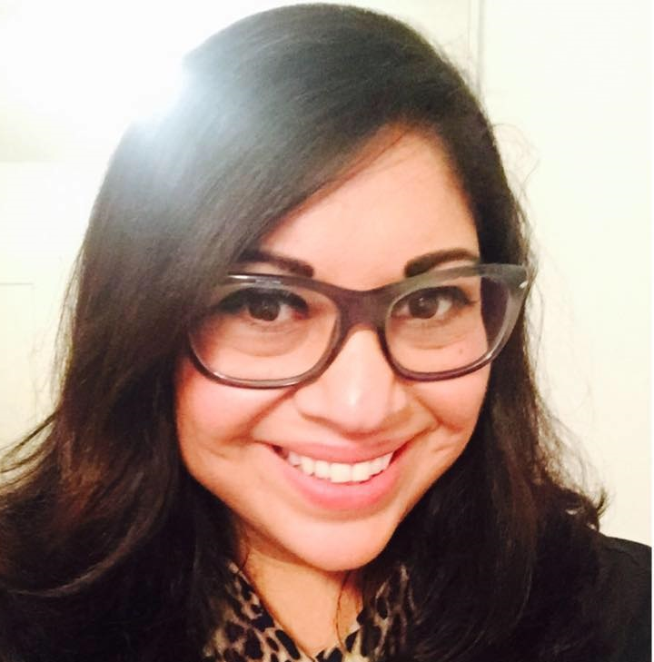
Ady Huertas is the Manager of the Logan Heights Branch Library in the San Diego Public Library System. She has 19 years of library work experience, an MLIS degree from San Jose State University and is a Eureka Fellow and Spetrum Scholar. Ady is the Chair of the Creando Enlaces Committee, which has put on five bi-national library conferences that bring together librarians for the U.S. and Mexico to collaborate and share best practices. She has been involved with REFORMA: The National Association to Promote Library and Information Services to Latinos and the Spanish Speaking for 9 years and has held leadership positions in the San Diego LIBROS Chapter as President in 2013. She is currently the REFORMA International Relations Committee Chair and is actively involved in the REFORMA Children in Crisis Task Force by offering services and access to books to unaccompanied immigrant and refugee youth in San Diego.

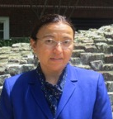
Laila Hussein Moustafa is an Assistant Professor & the Middle East and North Africa Studies Librarian at Illinois University in Urbana Champaign. She worked with International Human Rights organizations such as Human Rights First, Human Rights Watch and Amnesty. Laila studied in New York University and Long Island University in NY and she is specialize in the Middle East and Africa Studies Her Research focused on preserving rare and endangered cultural heritage materials in wartime and some of her recent work has appeared in Library Management, IFLA and International Leads –ALA. She is one of the Donor Board members of Arcadia, which is administered by the British Library.


Krystle Nguyen is the Planning Manager at Florida Hospital Alliance and Innovation eXchange (AIX), developing innovative partnerships to connect businesses of all sizes to Florida Hospital's health-care professionals to transform the future of health care. Krystle earned a Bachelor of Science degree in Health Services Administration from the University of Central Florida and is currently attending Rollins College Crummer Graduate School of Business to pursue a master's degree in Business Administration. Krystle's passion is to make an impact in the community and has over nine years of leadership experience with cultural and nonprofit organizations across Central Florida. During her undergraduate education at the University of Central Florida, Krystle strongly believed that collaborations and strategic alliances can help an organization become more successful. Her most notable leadership roles included becoming President of the Vietnamese American Student Association (VASA) in 2007, and Director of the Miss Vietnam Florida Pageant for the Vietnamese Community of Central Florida (VCCF) in 2010. She is currently on the Nominating Board for the City of Orlando and recommends qualified individuals for appointments to City and Multi-jurisdictional boards. Krystle also enjoys spending her free time exploring Orlando and created a blog to share her adventures on TheOrlandoGirl.com.

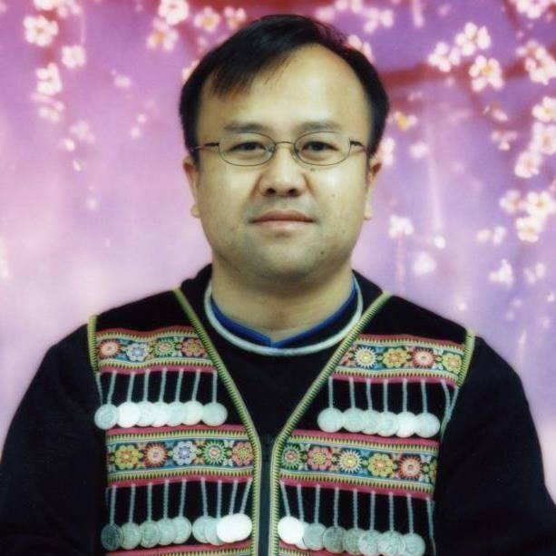
Touger Vang is Programming and Outreach Librarian at the Arthur F. Turner Community Library in West Sacramento, CA of the Yolo County Library. He holds a Master in Library and Information Studies from The University of North Carolina at Greensboro. Touger is a refugee from Laos and came to the United States at the age of 10 to resettle with his family in Mobile, Alabama. He has worked with refugees and first generation college students in North Carolina for over 15 years before moving to northern California. His experience and research with underrepresented populations informs his community-engaged approach in delivering library and information services. Raised in the Hmong tradition and growing up in the United States, he is aware of the value of preserving traditional cultural heritage and the need to provide multilingual information access in today’s culturally diverse communities.

Please join us for our remaining APALA Programs in Orlando

Saturday, June 25, 2016
3:00 – 4:00pm, ALA Diversity & Outreach Fair, Exhibit Hall – Special Events Area
4:00-6:00pm, Joint Council of Librarians of Color Fundraiser Reception,
Hyatt Regency Orlando, Manatee Springs I
6:30-9:30pm, Asian/Pacific American Award for Literature Awards Banquet,
Chutney’s Indian Restaurant, (Tickets available at the door, $40 members, $45 non-members)

Sunday, June 26, 2016
10:30-12:30pm, Film Screening & Panel Discussion: Now Showing @ ALA - Chinese Couplets,
Film Screening Area
2:00-4:00pm, APALA Membership & All Committee Meeting,
Hyatt Regency Orlando, Manatee Spring I

For more information on our panelists, events, and APALA, please visit www.apalaweb.org

